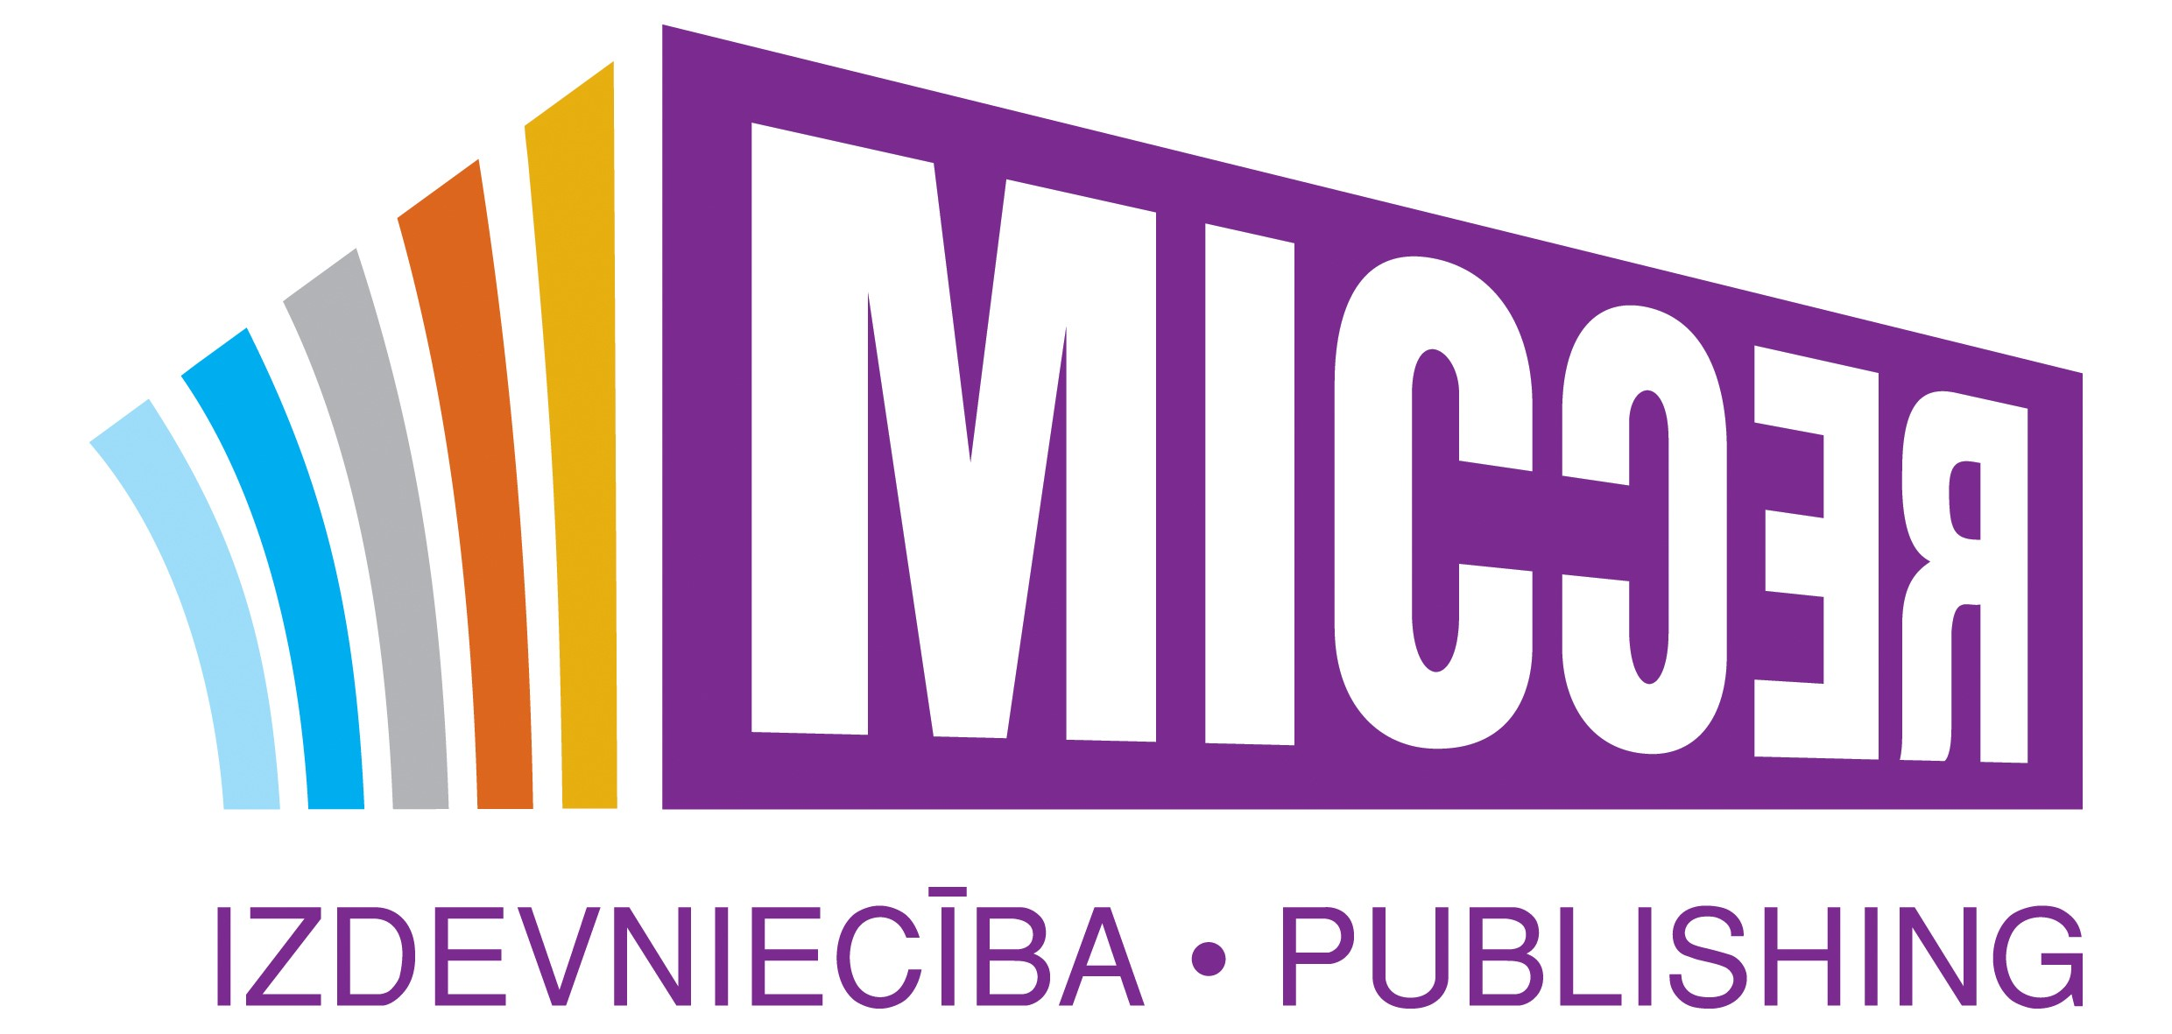

LICENSING REQUEST FOR SONG USE IN TV / MOVIE

Requestor’s contact info
Name:
Phone:
Email:

We would like to use in TV program / Movie the song mentioned below:

Title of original work:
Writer(s) of original work:
Artist of original work:

About TV Program / Movie
TV program / Movie title:
Producer:
TV Program / Movie disburse (budget):
Length of song in TV Program / Movie:
Is the master recording used or is this a re-recorded sampling?
Brief summary of storyline:
Brief description of episode:
Media:
Scheduled release date:
Territories of release:
Any useful additional details:
Proposed fee, based on 100%

Date:

Please do not hesitate to contact to use by email: info@micrecmusic.lv or phone +371 26374885; +371 25676743

